

PRCO204

GROUP X

REPORT

Joseph Stephens (10619861), Marc Rasell, Jack Edwards, Amoata Eyorekon

**Contents**

**1.0 Introduction**

1.1 Project Links: Website, GitHub, YouTube video

1.2 Our scenario

1.3 Assumptions made

**2.0 Understanding of Agile Philosophy and Approach Taken**

2.1 Agile approach rather than Waterfall

2.2 Resources consulted

2.3 Implementation of principles learned

**3.0 Project Management**

3.1 Roles taken by the team

3.2 Meetings and decisions, remote working

3.3 Communication

**4.0 Development of the Project**

4.1 Storyboard

4.2 Group meeting 1

4.21 Sprint 1

4.3 Group meeting 2

4.31 Sprint 2

4.4 Group meeting 3

4.41 Sprint 3

4.5 Group meeting 4

4.51 Sprint 4

4.6 Group meeting 5

4.61 Sprint 5

4.7 Group meeting 6

4.71 Sprint 6

4.8 Risk Assessment

4.81 Security Risk Assessment and Mitigation

4.9 Product Backlog

4.91 Product Release Plan

4.92 What was implemented and who implemented it

4.10 Screenshots of the solution and application factsheet

4.11 Problems encountered

**5.0 Database development**

5.1 Entity Relationship diagram

5.2 Procedures, views & triggers

5.3 Use case diagram

5.4 Normalization

5.5 SQL code

**6.0 Usability**

6.1 Usability test plan

6.2 Usability test results

6.3 Desirable changes

6.4 Fixes as a result of feedback

6.5 Usability testing evaluation

6.6 Accessibility

6.7 GDPR

**7.0 Lessons Learned**

7.1 Importance of regular meetings

7.2 Communication

7.3 Remote working

7.4 Coding as a Team

7.5 Identifying individual strengths in the team

**8.0 Conclusion**

8.1 Reflection of project successes/challenges

8.2 Personal development: teamworking, agile philosophy

8.3 Looking forward: what could have been done differently

**1.0 Introduction**

1.1 Project Links

Website: <http://web.socem.plymouth.ac.uk/intproj/prco204_x/index.php>

GitHub: <https://github.com/Plymouth-University/prco204-flight-crew>

YouTube video: <https://youtu.be/pEsjQm8e7MY>

1.2 Our scenario

As a team, we have designed an airline booking system. The system consists of a desktop and mobile compatible website which is connected to a single web API, connected to a MySQL database.

At its core, the system allows customers to book flights to selected countries. They can do this by searching for specific flights or checking currently available flights. Additionally, customers can view their previously and currently booked flights, pay for booked flights, cancel booked flights, and send secure messages to an employee.

Furthermore, customers can create an account and then view and edit their own account details. They can also delete their account from the database.

Administrators can create, update, and delete flights, journeys, and airports. Moreover, they can view ongoing flight statistics and an audit log showing all database interactions.

1.3 Assumptions made

* + The user has an existing email address and home address
  + The user is expected to enter details that exist - a real email, address etc.
  + Flight plan codes and destination codes are unique.
  + There is always at least one journey available.
  + The distance between two airports is calculated on a 2d pane.
  + The ticket price is always in pounds.
  + There is always enough seat capacity to accommodate a ticket purchase.
  + When searching, the customer knows their origin and desired destination.
  + When searching, the customer knows the exact date they wish to depart on.

**2.0 Understanding of Agile Philosophy and Approach Taken**

2.1 Agile approach rather than Waterfall

Our approach to the project differed from the usual Waterfall approach of completing the project step by step i.e. design, database, web, testing. Rather than complete each step completely we tried to focus on implementing pieces of functionality each sprint, building up the application step by step.

We defined 4 stages to the project in our story map and aimed to complete one stage per sprint over a two-week period. This approach worked well as it kept the project on track and allowed us to focus on small pieces of functionality at a time as a group. However, even small pieces of functionality could be complex, so breaking it down was the right approach.

This approach meant the design and testing would be developing as the project grew, which meant even the design was agile and could change.

2.2 Resources consulted

There were several online resources in the reading list for this module that helped guide the approach taken together with the recommended textbook, “Agile Software Development, Principles, Patterns and Practices”. These resources helped to provide the knowledge of the agile approach and how we were to define a project backlog and create two-week sprints to implement functionality into the application. They textbook suggested the use of xml for acceptance tests, and that OOP should only be implemented where necessary. These resources were useful given that we had no prior experience of using this methodology.

2.3 Implementation of principles learned

We planned the project in two-week sprints, implementing functionality from the stages in the story map. Each person in the team had their assigned role – project owner, scrum leader and technical lead. This helped to give different perspectives in the team meetings.

We gradually built up the functionality and we also had an acceptance test file in xml. Implementing unit testing was challenging because of the close integration of functions with the database. Automating the xml tests also seemed difficult so they were left as manual tests which could be run to check the site was working. This was not ideal but provided a way for testing.

**3.0 Project Management**

3.1 Roles taken by the team

To be completed by Jack Edwards

Product Owner- Amoata Eyorekon/Jack Edwards

Scrum Master - Joseph Stevens

Technical Lead - Marc Rasell

3.2 Meetings and decisions, remote working

To be completed by Jack Edwards

Decisions made

Decision 1:

Decision 1 Justification

3.3 Communication

To be completed by Jack Edwards

Formal Communication within the team handled by email, and Trello/Github Project Boards. Informal communication handled by Whatsapp group.

Tuckman’s stages of group development

<https://pubmed.ncbi.nlm.nih.gov/14314073/>

**4.0 Development of the Project**

Following the agile philosophy, we held regular meetings to assess our progress and as a chance to communicate as a group face to face to resolve any issues and provide any additional support for each other. Each meeting document lists the meeting details, records the actions we achieved within the meeting, the actions to be completed before the next meeting and any additional key information.

During the meeting we would decide on our next sprint, including its duration and workload. Each sprint document entails its running duration, outline of purpose, action plan and action review. The review section was updated at the end of the sprint as a record of how achievable the action plan was and to highlight any issues we may have had.

4.1 Initial Story board

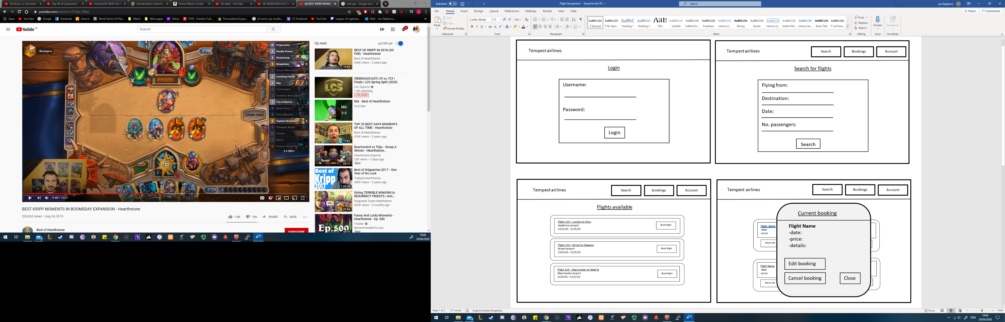

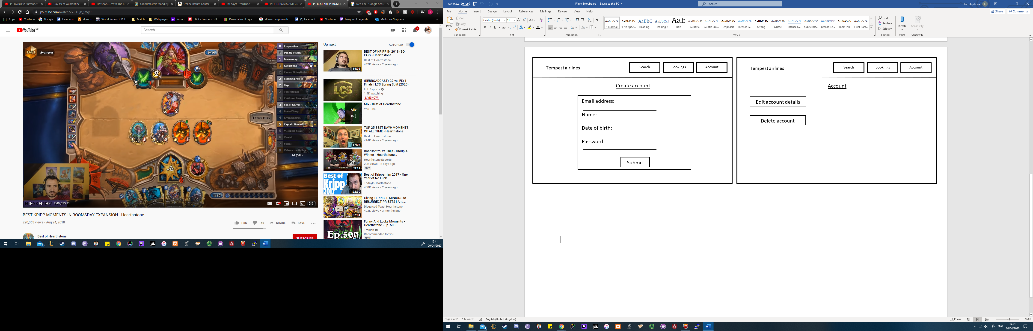

4.2 Group meeting 1

**Meeting 1**

Meeting details

Date: 7/2/20

Time: 09:00 – 10:30

Location: Babbage 208

Attendees: Joseph Stephens, Marc Rasell, Amoata Eyorekon

**Roles**

Product owner

Jack Edwards

Amoata Eyorekon

Scrum master

Joseph Stephens

Technical lead

Marc Rasell

Actions

* Decided on our roles.
* Decided to do the Security scenario. It will be a MVP flight application.
* Formed initial user stories.
* Set up GitHub repository
* Set up Trello team boards

Backlog

* For everyone to create a list of functionality and non-functional requirements.
* Think about potential risks to form an initial risk assessment.

Apologies

Jack sent his apologies for not attending due to personal reasons.

4.21 Sprint 1

**Sprint 1**

Initial functionality, requirements and risk analysis

Start date: 7/2/2020

End date: 14/2/2020

Purpose

The purpose of this sprint is to create initial user stories, functionality, product vision, risk assessment and roadmap.

Action plan

|  |  |  |  |  |
| --- | --- | --- | --- | --- |
| Task | Start date | Expected completion date | Expected time required  (hours) | To be completed by |
| Project risk assessment | 7th Feb | 14th Feb | 4 | Everyone – Each member will do their own risk assessment and will be merged into one. |
| Functional requirements | 7th Feb | 14th Feb | 3 | Everyone – Each member will do their own version of functional requirements and will be merged into one. |
| Customer user stories | 7th Feb | 12th Feb | 1 | Everyone |
| Admin user stories | 7th Feb | 12th Feb | 1 | Everyone |
| Non-functional requirements | 7th Feb | 14th Feb | 3 | Everyone - Each member will do their own version of functional requirements and will be merged into one. |
| Security risk assessment | 7th Feb | 14th Feb | 2 | Marc |

Sprint review

|  |  |  |  |  |
| --- | --- | --- | --- | --- |
| Task | Time required | Status | Expected time required to finish (hours) | Notes |
| Project risk assessment | 2 | Completed | 0 | Everyone made their own and best ideas were collated. |
| Functional requirements | 2 | Completed | 0 | Everyone made their own and best ideas were collated. |
| Customer user stories | 1 | Completed | 0 | Everyone made their own and best ideas were collated. |
| Admin user stories | 1 | Completed | 0 | Everyone made their own and best ideas were collated. |
| Non-functional requirements | 1 | Completed | 0 | Everyone made their own and best ideas were collated. |
| Security risk assessment | 1 | Completed | 0 |  |

4.3 Group meeting 2

**Meeting details**

Date: 14/2/2020

Time: 9:00am – 10:30am

Location: Babbage 208

Attendees: Joseph Stephens, Marc Rasell, Amoata Eyorekon

Actions

* Prepare for presentation by finalising user stories, product vision, risk assessment and roadmap.
* Delegate coding responsibilities.
* Decide upon common theme/layout.
* Uploaded and updated backlog on the repository.

Backlog

* Create new account
* Login
* Flight search
* Flight booking

Apologies

Jack sends his apologies for non-attendance due to personal reasons.

4.31 Sprint 2

**Sprint 2**

Start date: 14/2/2020

End date: 28/2/2020

Purpose

The purpose of this sprint is to finalise the general requirements, risk assessment and road map and prepare to present these documents on the 21/2/2020. We will also create the initial frontend and backend functionality.

Plan

|  |  |  |  |  |
| --- | --- | --- | --- | --- |
| Task | Start date | Expected completion date | Expected time required  (hours) | To be completed by |
| Use case diagram | 14th Feb | 20th Feb | 2 | Joseph |
| Create initial functionality – home page | 14th Feb | 28th Feb | 3 | Amoata |
| Create initial functionality - Booking a new flight | 14th Feb | 28th Feb | 2 | Jack |
| Create initial functionality – Customer creating an account | 14th Feb | 28th Feb | 3 | Joseph |
| Create initial functionality -Customer and Admin login | 14th Feb | 28th Feb | 3 | Amoata |
| Create initial functionality – Flight search | 14th Feb | 28th Feb | 2 | Jack |
| Create initial functionality – Database functionality | 14th Feb | 28th Feb | 4 | Marc |
| Create common footer | 14th Feb | 24st Feb | 1 | Marc |
| Create common header | 14th Feb | 24st Feb | 1 | Marc |
| Prepare presentation | 14th Feb | 20th Feb | 2 | Jack, Amoata - all members will prepare to present |
| Initial storyboard | 14th Feb | 22nd Feb | 2 | Everyone – all members will make one and will collate the best of each |

Sprint review

|  |  |  |  |  |
| --- | --- | --- | --- | --- |
| Task | Time required | Status | Expected time required to finish  (hours) | Notes |
| Use case diagram | 2 | Completed | 0 | Initial use case diagram for the initial functionality has been created. |
| Create initial functionality – home page | 3 | Completed | 0 | Has been created and is now undergoing usability testing. |
| Create initial functionality - Booking a new flight | 2 | Completed | 0 | Has been created and is now undergoing usability testing. |
| Create initial functionality – Customer creating an account | 3 | Completed | 0 | Has been created and is now undergoing usability testing. |
| Create initial functionality -Customer and Admin login | 3 | Completed | 0 | Has been created and is now undergoing usability testing. |
| Create initial functionality – Flight search | 2 | Completed | 0 | Has been created and is now undergoing usability testing. |
| Create initial functionality – Database functionality | 4 | Completed | 0 | All the foundations have been created including the tables, view and procedures. |
| Create common footer | 1 | Completed | 0 | We have a working common footer across the application. |
| Create common header | 1 | Completed | 0 | We have a working common footer across the application. |
| Prepare presentation | 1 | Completed | 0 | Presentation was prepared in time and presented by all members. |
| Initial storyboard | 2 | In Progress | 1 | Completed by members but now needs to be collated into a final version. |

4.4 Group meeting 3

**Meeting details**

Date: 28/2/2020

Time: 9:00am – 1pm

Location: Babbage 208

Attendees: Marc Rasell, Amoata Eyorekon, Jack Edwards

Actions

* Carried out a review of previous sprint. Updated the previous sprint file to show what has been completed.
* Agreed to work on the code on remote server rather than locally.
* Agreed on a coding plan. The first week of the sprint will be dedicated to coding the decided functionality with an emphasis on pair programming to make sure everyone is confident going forward. In the second week of this sprint we will begin to integrate our code.
* Plan for next week’s presentation.

Backlog

* Customer payment functionality
* Booking cancellation
* Admin login
* Add new flights (admin)
* Secure messaging system
* Usability plans, HCI feedback
* Revised user stories and risk assessment.

Apologies

Joseph sends his apologies for non-attendance due to illness.

4.41 Sprint 3

**Sprint 3**

Initial functionality, requirements and risk analysis

Start date: 28/2/2020

End date: 13/3/2020

Purpose

The purpose of this sprint is to begin coding the main functionality in a two-week period. The first week will be dedicated to coding with an emphasis on pair programming. The second week will be used to integrate the code and generate tests. We will also revise our user stories and risk assessment in accordance to our progress, usability plans and HCI feedback.

Plan

|  |  |  |  |  |
| --- | --- | --- | --- | --- |
| Task | Start date | Expected completion date | Expected time required  (hours) | To be completed by |
| Create functionality – Customer payment | 28th Feb | 13th March | 2 | Amoata |
| Create functionality – Cancelling a booking | 28th Feb | 13th March | 2 | Jack |
| Create functionality – Admin login | 28th Feb | 13th March | 2 | Marc |
| Create functionality – Add new flights (admin) | 28th Feb | 13th March | 2 | Marc |
| Create functionality – Secure messaging system | 28th Feb | 13th March | 3 | Jack |
| Usability plan | 28th Feb | 13th March | 2 | Joseph, Jack |
| Refine user stories | 28th Feb | 13th March | 1 | Jack |
| Refine risk assessment | 28th Feb | 13th March | 1 | Jack |
| Prepare presentation (on product goals, backlog, achieved and planned sprints) | 28th Feb | 5th March | 2 | all members will prepare and present |
| HCI initial test planning | 28th Feb | 6th March | 1 | Joseph, Jack |
| Collate final storyboard | 28th Feb | 6th March | 2 | Joseph |

Sprint review

|  |  |  |  |  |
| --- | --- | --- | --- | --- |
| Task | Time required | Status | Expected time required to finish  (hours) | Notes |
| Create functionality – Customer payment | 2 | Completed | 0 | Has been created and is now undergoing usability testing. |
| Create functionality – Cancelling a booking | 2 | Completed | 0 | Has been created and is now undergoing usability testing. |
| Create functionality – Admin login | 2 | Completed | 0 | Functionality was created and interface was updated according to initial usability testing. |
| Create functionality – Add new flights (admin) | 2 | Completed | 0 | Has been created and is now undergoing usability testing. |
| Create functionality – Secure messaging system | 2 | Completed | 0 | Functionality was created and interface was updated according to initial usability testing. |
| Usability plan | 2 | Completed | 0 | An initial plan for how our usability tests should be conducted |
| Refine user stories | 2 | Completed | 0 | Made the user stories more specific. |
| Refine risk assessment | 2 | Completed | 0 | Updated the risk assessment in accordance to our progress. |
| Prepare presentation (on web functionality, storymap & HCI feedback) | 2 | Completed | 0 | Presentation was created and presented. |
| HCI initial test planning | 3 | In-progress | 1 | We have created 26 usability scenarios ready to be tested. We will create the final 4 tests when the functionality for them is in place. Pushed into the next sprint. |
| Collate final storyboard | 2 | Completed | 0 | Everyone’s initial storyboard ideas where collated into a final version. |

4.5 Group meeting 4

**Meeting details**

Date: 13/3/2020

Time: 9:00am – 1pm

Location: Babbage 208

Attendees: Joseph Stephens, Marc Rasell, Jack Edwards, Amoata Eyorekon

Actions

* Carried out a review of previous sprint. Updated the previous sprint file to show what has been completed.
* Created next sprint
* Agree on HCI test to be carried out the following session.
* Setup shared document for final report.
* Plan for next week’s presentation.

Backlog

* Delete customer account functionality
* Create admin stats functionality
* Create admin security log
* Create HCI tests
* Continue with acceptance tests for all coding

4.51 Sprint 4

**Sprint 4**

Admin functionality, HCI testing and final report planning

Start date: 13/3/2020

End date: 27/3/2020

Purpose

The purpose of this sprint is to implement the final two stages of our story map. This includes the final functionality, HCI testing and documentation. The first week will be dedicated to admin functionality and creating HCI tests and the second week will be for reviewing the results of the usability tests and implementing any feedback.

Plan

|  |  |  |  |  |
| --- | --- | --- | --- | --- |
| Task | Start date | Expected completion date | Expected time required  (hours) | To be completed by |
| Create functionality – Delete Customer account | 13th | 27th | 2 | Amoata |
| Create functionality – admin stats | 13th | 27th | 4 | Jack |
| Create functionality – audit log | 13th | 27th | 3 | Marc |
| Plan final report | 13th | 27th | 2 | Joseph |
| Prepare presentation (on product goals, backlog, achieved and planned sprints) | 13th | 27th | 2 | all members will prepare and present |
| Acceptance tests | 13th | 27th | 4 | Everyone |
| HCI tests | 13th | 17th | 4 | Joseph, Jack |
| UML diagrams | 13th | 27th | 3 | Everyone |

Sprint review

|  |  |  |  |  |
| --- | --- | --- | --- | --- |
| Task | Time required | Status | Expected time required to finish  (hours) | Notes |
| Create functionality – Delete Customer account | 3 | Completed | 0 | Has been created and is now undergoing usability testing. |
| Create functionality – admin stats | 2 | Completed | 0 | Has been created and is now undergoing usability testing. |
| Create functionality – audit log | 2 | Completed | 0 | Has been created and is now undergoing usability testing. |
| Plan final report | 2 | Completed | 0 | The front page and contents have been created. A general layout has been added. |
| Prepare presentation (on product goals, backlog, achieved and planned sprints) | 1 | Completed | 0 | Presentation was created and presented by everyone. |
| Acceptance tests | 1 | In-progress | 3 | Not fully completed. Has been pushed to the next sprint. |
| HCI tests | 4 | Completed | 0 | All 30 scenarios were created and have been tested by users. |
| UML diagrams | 3 | In-progress | 3 | Not fully completed. Has been pushed to the next sprint. |

4.6 Group meeting 5

**Meeting details**

Date: 27/3/2020

Time: 10am – 11am

Location: Zoom

Attendees: Joseph Stephens, Marc Rasell, Jack Edwards, Amoata Eyorekon

Actions

* Carried out a review of previous sprint. Updated the previous sprint file to show what has been completed.
* Created next sprint
* Gave presentation on current progress
* Planned communication for over Easter break (zoom).

Backlog

* Haversine functionality integration
* Integrate HCI feedback
* Continue with acceptance tests for all coding
* Continue adding to final report
* UML diagrams
* LSEP issues
* Factsheet

4.61 Sprint 5

**Sprint 5**

HCI feedback integration, report planning and key documentation

Start date: 27/3/2020 (Easter)

End date: 24/4/2020

Purpose

The purpose of this sprint is to integrate the feedback we have received from our HCI testing, focus on LSEP issues, continue key documentation and add to the final report. This will be a 4-week sprint as it will run over Easter break.

Plan

|  |  |  |  |  |
| --- | --- | --- | --- | --- |
| Task | Start date | Expected completion date | Expected time required  (hours) | To be completed by |
| Create functionality – haversine functionality | 27th March | 24th April | 1 | Jack |
| LSEP: Legal, Professional | 27th March | 24th April | 2 | Marc |
| LSEP: Social (accessibility) | 27th March | 24th April | 3 | Joseph |
| Application factsheet | 27th March | 24th April | 2 | Jack |
| HCI review and implementation | 27th March | 24th April | 4 | Joseph |
| Continue Final report | 27th March | 24th April | 20 | Everyone |
| Acceptance tests | 13th March | 24th April | 3 | Everyone |
| UML diagrams | 13th March | 24th April | 3 | Everyone |

Sprint review

|  |  |  |  |  |
| --- | --- | --- | --- | --- |
| Task | Time required | Status | Expected time required to finish  (hours) | Notes |
| Create functionality – haversine functionality | 1 | In Progress | 1 | Coding completed. Waiting for implementation. |
| LSEP: Legal, Professional | 2 | Complete | 0 | Updated terms and conditions and legal footer. |
| LSEP: Social (accessibility) | 3 | Complete | 0 | Added a more encompassing colour scheme and increased size of buttons. |
| Application factsheet | 2 | In Progress | 2 | Continually adding more to the factsheet as we add more functionality. |
| HCI review and implementation | 4 | In Progress | 1 | Wrote up feedback. Currently implementing desirable changes and bugfixes. |
| Continue Final report | 20 | In Progress | 7 | Report has been separated into parts and is continually being added too. |
| Acceptance tests | 3 | In Progress | 1 | Creating more tests as final code is added. |
| UML diagrams | 3 | Complete | 0 | Added to the report. |

4.7 Group meeting 6

**Meeting details**

Date: 24/4/20

Time: 9:45am – 11am

Location: Zoom

Attendees: Joseph Stephens, Marc Rasell, Jack Edwards, Amoata Eyorekon

Actions

* Carried out a review of previous sprint. Updated the previous sprint file to show what has been completed.
* Created final sprint and set end goals with a strict timeline.
* Reviewed final report and which sections to do next.
* Setup shared document for project management review.
* Plan for next week’s final presentation.
* Resolved any issues and problems raised during Easter break.

Backlog

* Continue with acceptance tests for all coding.
* Project management review.
* Continue final report.
* Create YouTube video showing complete application.
* Implement haversine functionality.
* Implement desirable changes from HCI feedback.
* Create application factsheet.
* Populate the database with dummy data.

4.71 Sprint 6

To be completed by Joseph Stephens (awaiting sprint review)

4.8 Risk Assessment

Our initial risk assessment detailed the risks the group anticipated could cause issues, as well as an assessment of the likelihood of the risk, the effect that risk coming to pass would have on the project, and a planned mitigation to either lower the chances of the risk, or a plan to enact if the risk happened. This risk assessment was to be updated on a sprint by sprint basis.

Sprint 1 Risk assessment

The initial risks were laid out as seen in the figure below. The risk chance was calculated at an optimistic, but realistic level. The three notable risks looked at in this sprint were as follows:

* Team members unwell or personal crisis
* Over or underestimating work that can be achieved in a sprint
* Team members struggling with coding

These risks were notable because they were the ones assessed to have a medium or above chance of happening, for a couple of reasons. Team members being unwell or having a personal crisis being graded at a medium-high seemed pertinent, owing to the fact that Product owner Jack Edwards was at the time experiencing issues due to severe medical complications in his family. The reason for the other two risks being graded at the level they were was due to the fact that the group was newly formed, with no prior knowledge of the member’s skills and commitments. With this in mind, suitable mitigation plans were made (also seen below), with the risk assessment to be revisted each sprint and updated as necessary.

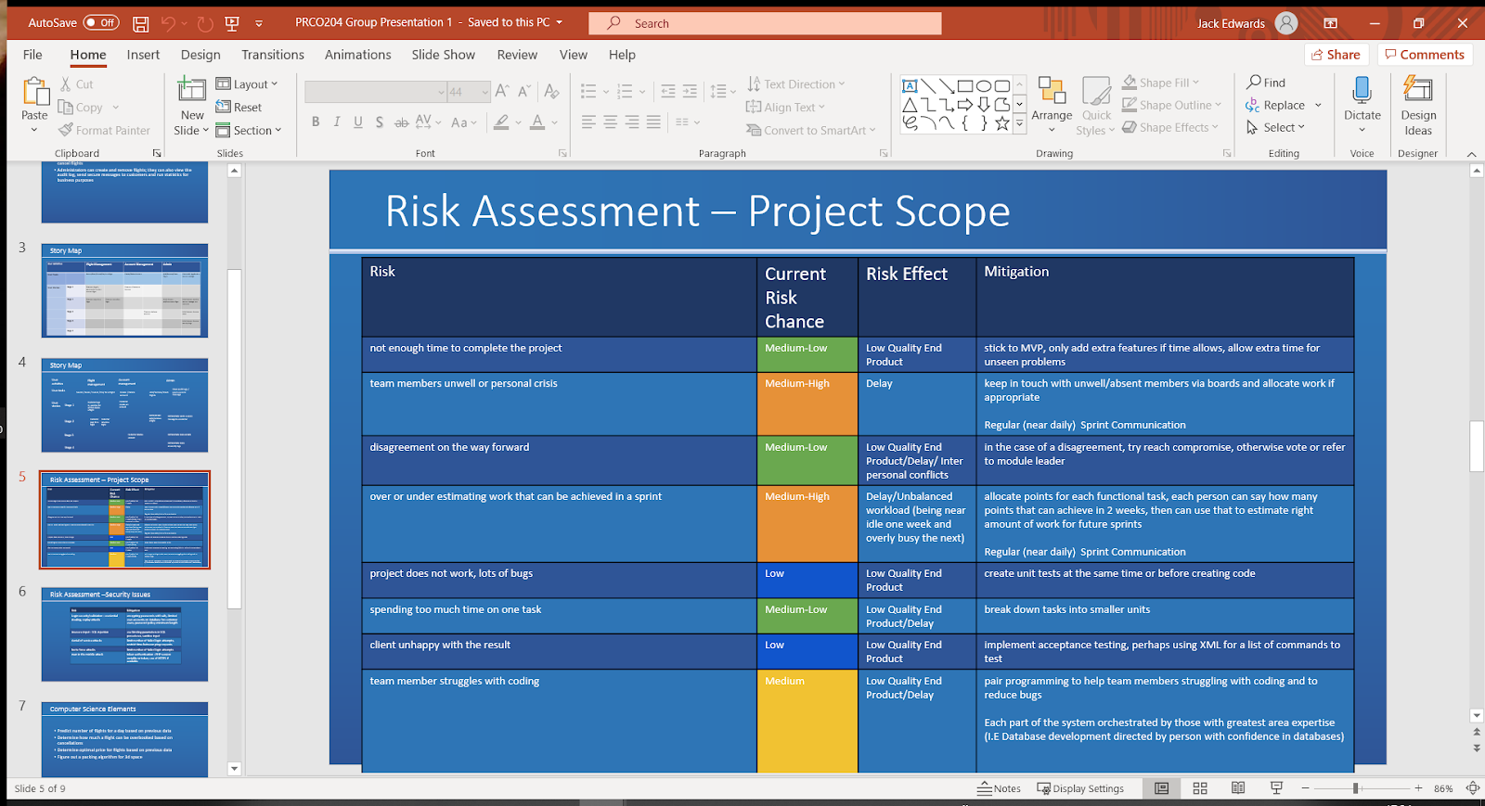

Sprint 2 Risk Assessment

When it came to the second sprint, the risk chances were updated as necessary. It was felt at this point that there was a slightly lower level of confidence in the group’s ability to produce bug free code, so the risk chance was upgraded from low to medium - low. This can be attributed to the fact that more code was being produced, and thus there was a greater chance of bugs. However, a greater understanding of group member’s abilities was had by this point, so downgrading over or underestimating amount of work that can be achieved from a medium high to a medium also seemed reasonable. 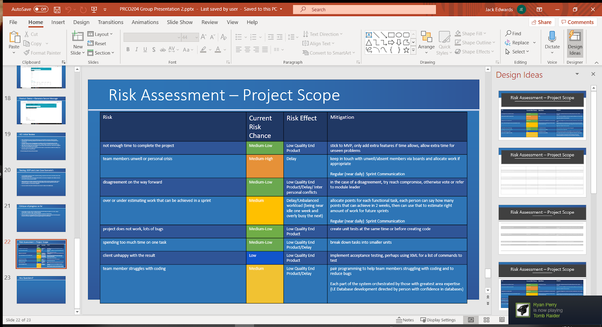

4.81 Security Risk Assessment and Mitigation

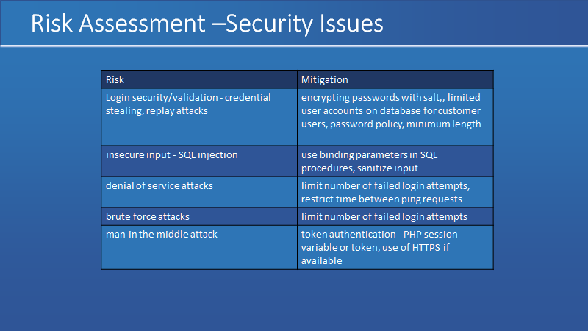

Passwords were hashed in the database for security, if we had been able to implement https this could have enhanced security to stop the plain text passwords being sent to the server unencrypted.

Binding parameters were used in the “database.php” file to prevent SQL injection attacks. And all user input was put through the “secure_input.php” function to remove any dangerous characters.

If we had more time, we could have added the failed login attempts functionality by adding a failed number of login attempts to the customer table.

4.9 Product Backlog

To be completed by Jack Edwards

4.91 Product Release Plan

To be completed by Jack Edwards

4.92 what was implemented and who implemented it

To be completed by Jack Edwards

4.10 Screenshots of the solution and application factsheet

To be completed by Jack Edwards

4.11 Problems encountered

To be completed by Jack Edwards

Covid19 Pandemic

On March 11th, 2019, the world health organization declared a global pandemic, due to a influenza like disease designated COVID-19. On March 23rd, UK Prime minister Boris Johnson declared the country in a state of lockdown. Non-essential travel was banned, all non-essential work was cancelled, all businesses deemed as not essential were shut down. The populace was told to remain in their homes, only allowed out for gathering essentials, and daily exercise. Plymouth University campus was shut down, with all face to face teaching including lectures, tutor meetings and practicals. This crisis affected not just our group but was a traumatic event on a global level. As compared to other groups operating in other faculties within the university, our group was probably better adjusted to this. The group operated a remote repository for the codebase and documents, had pre-existing lines of communication, and had a pre allocated space already established on the university servers. Nonetheless, it would not be unfair to say this event affected us greatly. It had a severe effect on our productivity, limiting our working space, and detrimenting our physical and mental wellbeing. This, in the authors opinion, does not seem unreasonable. There was no way within the scope of our group we could have predicted this event, nor were there any further reasonable measures we could have taken to account for the loss in productivity.

<https://www.bbc.co.uk/news/world-52103747>

**5.0 Database development**

5.1 Entity Relationship Diagram

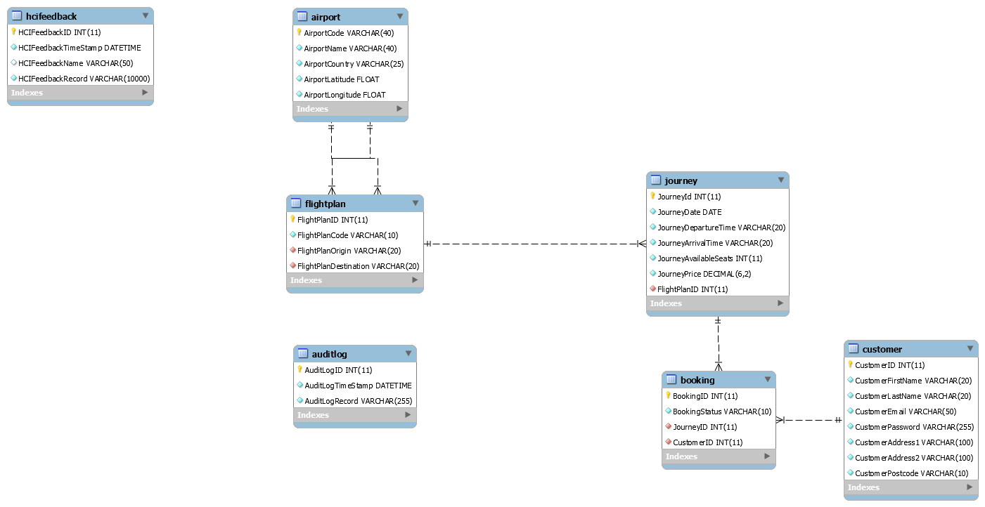

5.2 Procedures, Views and Triggers

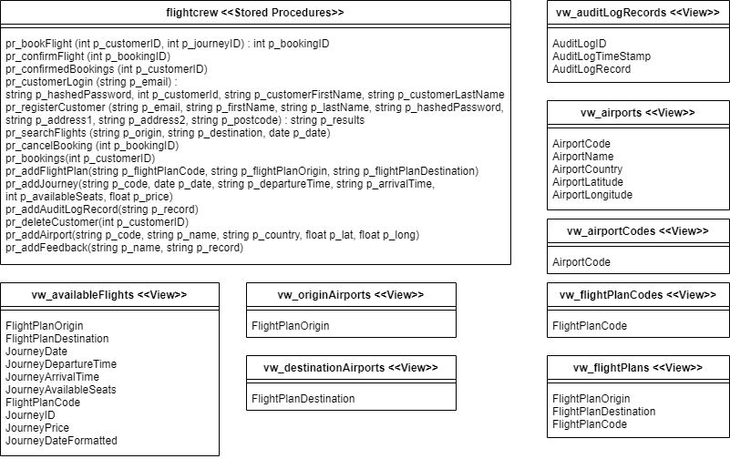

5.3 Use case diagram

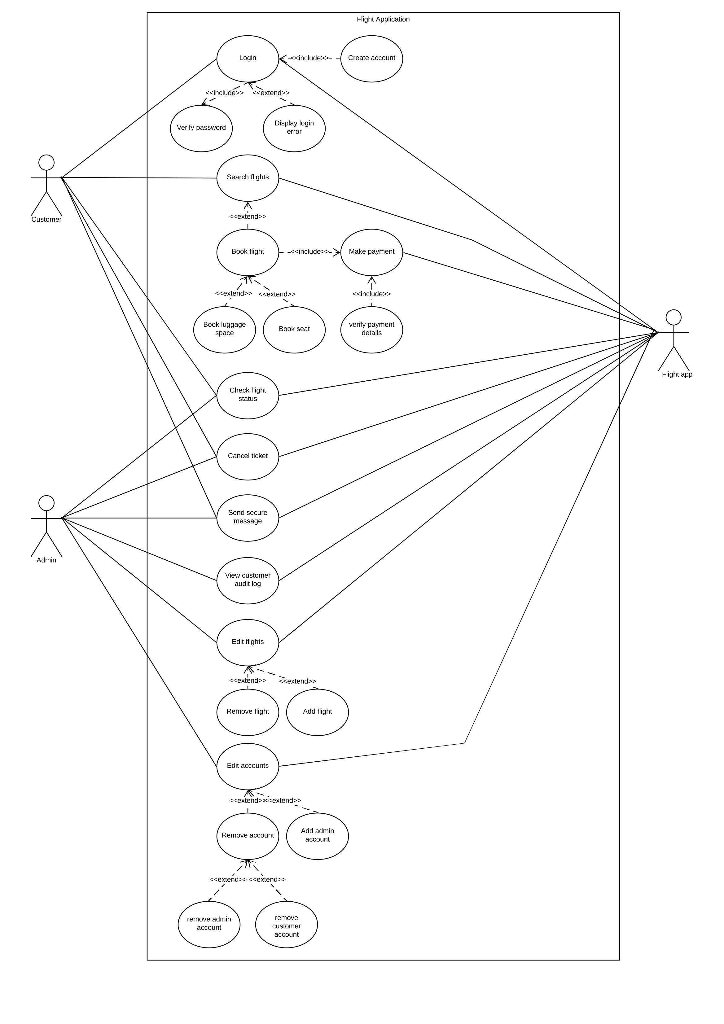

5.4 Normalization

|  |  |  |  |
| --- | --- | --- | --- |
| **UNF** | **1NF** | **2NF** | **3NF** |
|  |  |  |  |
| **JourneyID** | **JourneyID** | **JourneyID** | **JourneyID** |
| JourneyStartTime | JourneyStartTime | JourneyStartTime | *FlightPlanId |
| JourneyEndTime | JourneyEndTime | JourneyEndTime | JourneyStartTime |
| JourneyAvailableSeats | JourneyAvailableSeats | JourneyAvailableSeats | JourneyEndTime |
| FlightPlanId | FlightPlanId | FlightPlanId | JourneyAvailableSeats |
| FlightPlanOrigin | FlightPlanOrigin | FlightPlanOrigin |  |
| FlightPlanDestination | FlightPlanDestination | FlightPlanDestination | **FlightPlanId** |
| (BookingID |  |  | FlightPlanOrigin |
| BookingPaid | **JourneyID** | **BookingID** | FlightPlanDestination |
| CustomerID | **BookingID** | BookingPaid |  |
| CustomerFirstName | BookingPaid |  | **CustomerID** |
| CustomerLastName | CustomerID | **JourneyID** | CustomerFirstName |
| CustomerAddress | CustomerFirstName | **BookingID** | CustomerLastName |
| CustomerPostCode | CustomerLastName | CustomerID | CustomerAddress |
| CustomerPhoneNumber | CustomerAddress | CustomerFirstName | CustomerPostCode |
| CustomerEmail | CustomerPostCode | CustomerLastName | CustomerPhoneNumber |
| CustomerPassword) | CustomerPhoneNumber | CustomerAddress | CustomerEmail |
|  | CustomerEmail | CustomerPostCode | CustomerPassword |
|  | CustomerPassword | CustomerPhoneNumber |  |
|  |  | CustomerEmail | **BookingID** |
|  |  | CustomerPassword | *JourneyID |
|  |  |  | *CustomerID |
|  |  |  | BookingPaid |

5.5 SQL code

**6.0 Usability**

6.1Usability test plan

For our usability testing, we prepared 30 scenarios that test our user stories. We split the 30 scenarios into three different tests of 10 scenarios each. Each user was asked to record their test and email us the completed feedback form and voiceover.

We prepared specific instructions to be able to ask a user what to do without guiding them too much. Originally, we wanted to gather as much information as possible from a user’s first use experience. However, as we could not meet face-to-face with the user as originally planned, we knew we would not be able to give a brief tour of the application to give the user a basic understanding of the layout. Therefore, we accounted for the additional time it may take a user to complete each task without any previous knowledge of how the application works.

During testing, the user was asked to carry out 10 different tasks on the application. We prepared any necessary data for the user such as any login details or details to create an account. A thinking out loud approach was asked so that we could review a user’s thought process to be able to assess the difficulty of each task.

After each completed task, the user was asked to fill out a feedback form as shown below:

Time taken:

|  |  |  |  |  |
| --- | --- | --- | --- | --- |
| Which of the following would best describe the difficulty of this task? (check one box) | | | | |
| Very Easy | Moderately Easy | Neutral | Moderately Hard | Very Hard |
|  |  |  |  |  |

|  |
| --- |
| What you felt went well |
|  |
| What you felt could be improved |
|  |
| Other things worth mentioning |
|  |

6.2 Usability test results

**TEST 1**

**Scenario 1:**

User Story: As a customer, I want to be able to create an account in order to access the system's functionality.

Instructions: From the home page, click the ‘customer login’ button in the top right corner of the page. You will be met with a login form. Using the details provided, enter the relevant fields and click ‘Create account’ at the bottom of the form.

Please use the following details when creating an account:

1. Email: holidaygoer@outlook.com
2. First name: Susan
3. Last name: Jones
4. Address1: Portland Square
5. Address2: Plymouth
6. Postcode: PL49AJ
7. Password: UserTest789
8. Confirm Password: UserTest789

Time taken: 2mins 13secs

|  |  |  |  |  |
| --- | --- | --- | --- | --- |
| Which of the following would best describe the difficulty of this task? (check one box) | | | | |
| Very Easy | Moderately Easy | Neutral | Moderately Hard | Very Hard |
|  | x |  |  |  |

|  |
| --- |
| What you felt went well |
| The actual form is easy to understand |
| What you felt could be improved |
| The create account button could be moved more separately from the rest of the login page. The register button is less clear than the terms and conditions button so my eye’s weren’t as drawn to it as they could be. |
| Other things worth mentioning |
| I would make the terms and conditions a hyperlink rather than a button. |

**Scenario 2:**

User Story: As a Customer, I want to log in so I can use the system's functionality

Instructions: From the home page, click the ‘customer login’ button in the top right corner of the page. You will be met with a login form. Using the details provided, enter the relevant fields and click Login.

1. Email: [holidaygoer@outlook.com](mailto:holidaygoer@outlook.com)
2. Password: UserTest789

Time taken: 8secs

|  |  |  |  |  |
| --- | --- | --- | --- | --- |
| Which of the following would best describe the difficulty of this task? (check one box) | | | | |
| Very Easy | Moderately Easy | Neutral | Moderately Hard | Very Hard |
| x |  |  |  |  |

|  |
| --- |
| What you felt went well |
| Easy to get to and clear where to enter the information |
| What you felt could be improved |
| Perhaps making the login button stand out more |
| Other things worth mentioning |
| Again, moving the create account button away from the rest of the form |

**Scenario 3:**

User Story: As a customer, I want to be able to book flights online.

Instructions: Navigate to the home page by clicking the ‘Home’ button in the menu bar. Observe the list of flights. Book a flight from London to New York.

Time taken: 6secs

|  |  |  |  |  |
| --- | --- | --- | --- | --- |
| Which of the following would best describe the difficulty of this task? (check one box) | | | | |
| Very Easy | Moderately Easy | Neutral | Moderately Hard | Very Hard |
| x |  |  |  |  |

|  |
| --- |
| What you felt went well |
| Very straightforward and |
| What you felt could be improved |
| Perhaps using an alternating colour for the rows to make it easier to read. |
| Other things worth mentioning |
| n/a |

**Scenario 4:**

User Story: As a customer, I want to be able to check my current bookings.

Instructions: From the home page, click the ‘Bookings’ tab in the menu bar. You will be shown your current bookings.

Time taken:

|  |  |  |  |  |
| --- | --- | --- | --- | --- |
| Which of the following would best describe the difficulty of this task? (check one box) | | | | |
| Very Easy | Moderately Easy | Neutral | Moderately Hard | Very Hard |
| x |  |  |  |  |

|  |
| --- |
| What you felt went well |
| Again easy to navigate to. Clear difference between confirmed and unconfirmed bookings. |
| What you felt could be improved |
| Again, alternating row colours to help differentiate the bookings from each other |
| Other things worth mentioning |
| n/a |

**Scenario 5:**

User Story: As a customer, I want to be able to search through available flights so that I can find a flight that fulfils my need (Time/Date, Departure and Arrival Destination, Cost).

Instructions: Navigate to the “Search for a flight” tab. Search for a flight between London and Zurich on the 09/07/2020. Observe the result. Remain on this results page for the next scenario.

Time taken: 20secs

|  |  |  |  |  |
| --- | --- | --- | --- | --- |
| Which of the following would best describe the difficulty of this task? (check one box) | | | | |
| Very Easy | Moderately Easy | Neutral | Moderately Hard | Very Hard |
|  | x |  |  |  |

|  |
| --- |
| What you felt went well |
| The drop down boxes help not to overwhelm a user |
| What you felt could be improved |
| There were two London’s and two Zurichs which was confusing |
| Other things worth mentioning |
| n/a |

**Scenario 6:**

User Story: As a customer, I want to be able to book flights online.

Instructions: From the search results, book the flight from London to Zurich on the 09/07/2020.

Time taken: 3secs

|  |  |  |  |  |
| --- | --- | --- | --- | --- |
| Which of the following would best describe the difficulty of this task? (check one box) | | | | |
| Very Easy | Moderately Easy | Neutral | Moderately Hard | Very Hard |
| x |  |  |  |  |

|  |
| --- |
| What you felt went well |
| Very easy to locate the book button, good to have the flight booked message |
| What you felt could be improved |
| n/a |
| Other things worth mentioning |
| n/a |

**Scenario 7:**

User Story: As a customer, I want to be able to cancel a flight and receive a refund.

Instructions: Navigate to the ‘Bookings’ page. Observe the flights booked. Cancel the flight booked between London and New York on the 09/07/2020.

Time taken: 6secs

|  |  |  |  |  |
| --- | --- | --- | --- | --- |
| Which of the following would best describe the difficulty of this task? (check one box) | | | | |
| Very Easy | Moderately Easy | Neutral | Moderately Hard | Very Hard |
|  | x |  |  |  |

|  |
| --- |
| What you felt went well |
| Easy to get to the page, cancel button clear, good confirmation after. |
| What you felt could be improved |
| Perhaps some kind of “Are you sure” function as it is possible to cancel by accident |
| Other things worth mentioning |
| The task and the flights didn’t match properly |

**Scenario 8:**

User Story: As a customer, I want to be able to pay for a flight I have booked.

Instructions: Navigate to the ‘Bookings’ page. Pay for the flight from Alicante to Paris on the 03/08/2020. This should now be confirmed. Click the ‘Bookings’ tab in the menu bar once again and observe that the flight has now been confirmed.

Time taken:

|  |  |  |  |  |
| --- | --- | --- | --- | --- |
| Which of the following would best describe the difficulty of this task? (check one box) | | | | |
| Very Easy | Moderately Easy | Neutral | Moderately Hard | Very Hard |
| x |  |  |  |  |

|  |
| --- |
| What you felt went well |
| Easy to get to the page, cancel button clear, good confirmation after. |
| What you felt could be improved |
| The confirmation would look more professional with capitalisation |
| Other things worth mentioning |
| The task and the flights didn’t match properly |

**Scenario 9:**

User Story: As a Customer, I want to be able to send a secure message to airline employees so I can get help effectively.

Instructions: From the home page, click the ‘Contact’ tab. Tick the ‘Encrypt’ box at the bottom and enter the following message: “Hello, how do I book a flight?”. Then click calculate. The result should be:” Khoor, krz gr l errn d ioljkw?”.

Time taken: 10secs

|  |  |  |  |  |
| --- | --- | --- | --- | --- |
| Which of the following would best describe the difficulty of this task? (check one box) | | | | |
| Very Easy | Moderately Easy | Neutral | Moderately Hard | Very Hard |
| x |  |  |  |  |

|  |
| --- |
| What you felt went well |
| Easy to get to the page, clear result |
| What you felt could be improved |
| Consistency with the button style across the website |
| Other things worth mentioning |
| n/a |

**Scenario 10:**

User Story: As a customer, I want to be able to log out of my account after I have finished using the application.

Instructions: From the home page, click the ‘Logout’ button in the top right corner of the page. You should receive confirmation of a successful logout.

Time taken: 3secs

|  |  |  |  |  |
| --- | --- | --- | --- | --- |
| Which of the following would best describe the difficulty of this task? (check one box) | | | | |
| Very Easy | Moderately Easy | Neutral | Moderately Hard | Very Hard |
| x |  |  |  |  |

|  |
| --- |
| What you felt went well |
| Easy to logout, good confirmation message |
| What you felt could be improved |
| Adding an “Are you sure you want to logout” to prevent accidental logging out |
| Other things worth mentioning |
| n/a |

**TEST 2**

**Scenario 1:**

User Story: As an Admin, I want to log in so I can use the system's functionality.

Instructions: From the home page, click the ‘admin login’ button in the top right corner of the page. You will be met will a login form. Using the details provided, enter the relevant fields and click Login.

Please use the following details when logging in:

1. Username: admin
2. Password: pass1

Time taken: 5secs

|  |  |  |  |  |
| --- | --- | --- | --- | --- |
| Which of the following would best describe the difficulty of this task? (check one box) | | | | |
| Very Easy | Moderately Easy | Neutral | Moderately Hard | Very Hard |
| x |  |  |  |  |

|  |
| --- |
| What you felt went well |
| Clear to navigate to |
| What you felt could be improved |
| Consistent buttons |
| Other things worth mentioning |
| n/a |

**Scenario 2:**

User Story: As an Admin, I want to be able to check the status of current flights.

Instructions: From the home page, click the ‘Add Flight’ tab in the menu bar. Observe the current flight plans at the bottom of the page.

Time taken: 15 secs

|  |  |  |  |  |
| --- | --- | --- | --- | --- |
| Which of the following would best describe the difficulty of this task? (check one box) | | | | |
| Very Easy | Moderately Easy | Neutral | Moderately Hard | Very Hard |
| x |  |  |  |  |

|  |
| --- |
| What you felt went well |
| Easy to navigate |
| What you felt could be improved |
| Went I tried to return to the page later it stopped working then started working again later |
| Other things worth mentioning |
|  |

**Scenario 2:**

User Story: As an Admin, I want to send a secure message to other employees and customers.

Instructions: From the home page, click the ‘Contact’ tab in the menu bar. Tick the ‘Encrypt’ box at the bottom and enter the following message into the text field: Welcome to Tempest Airlines. Click calculate. The result should be: Zhofrph wr Whpshvw Dluolqhv

Time taken:

|  |  |  |  |  |
| --- | --- | --- | --- | --- |
| Which of the following would best describe the difficulty of this task? (check one box) | | | | |
| Very Easy | Moderately Easy | Neutral | Moderately Hard | Very Hard |
| x |  |  |  |  |

|  |
| --- |
| What you felt went well |
| Easy to navigate to |
| What you felt could be improved |
| n/a |
| Other things worth mentioning |
| n/a |

**Scenario 3:**

User Story: As an Admin, I want to be able to decrypt a secure message I have received.

Instructions: From the home page, click the ‘Contact’ tab in the menu bar. Tick the ‘Decrypt’ box at the bottom and enter the result from the previous scenario into the text field: Zhofrph wr Whpshvw Dluolqhv. Click calculate. The result should be: Welcome to Tempest Airlines

Time taken: 10 secs

|  |  |  |  |  |
| --- | --- | --- | --- | --- |
| Which of the following would best describe the difficulty of this task? (check one box) | | | | |
| Very Easy | Moderately Easy | Neutral | Moderately Hard | Very Hard |
| x |  |  |  |  |

|  |
| --- |
| What you felt went well |
| Easy to find, clear response |
| What you felt could be improved |
| Maybe include the response on the same page? |
| Other things worth mentioning |
| n/a |

**Scenario 4:**

User Story: As an Admin, I want to be able to add a new Airport to the database.

Instructions: From the home page, navigate to the ‘Add Airport’ tab. You will be met with a details form. Using the details provided, enter the relevant fields and then click ‘add’:

1. Code: Tokyo (TKY)
2. Name: Tokyo Airport
3. Country: Japan
4. Latitude: 35.553333
5. Longitude: 139.781113

You should receive confirmation that the airport has been added. Navigate to the ‘Add Airport’ tab in the menu bar once again and check that the new airport is in the ‘Current Airports’ list at the bottom of the page.

Time taken: 26secs

|  |  |  |  |  |
| --- | --- | --- | --- | --- |
| Which of the following would best describe the difficulty of this task? (check one box) | | | | |
| Very Easy | Moderately Easy | Neutral | Moderately Hard | Very Hard |
|  | x |  |  |  |

|  |
| --- |
| What you felt went well |
| Clear layout |
| What you felt could be improved |
| The exact lat and long couldn’t be entered due to a length limit |
| Other things worth mentioning |
| n/a |

**Scenario 5:**

User Story: As an Admin, I want to be able to add a new journey to the database.

Instructions: From the home page, navigate to the ‘Add Journey’ tab. You will be met with a details form. Using the details provided, enter the relevant fields and then click ‘add’:

1. Flight Plan Code: LZR400
2. Journey Date: 30/08/2020
3. Departure Time: 10:00
4. Arrival Time: 14:00
5. Available Seats: 80
6. Price: 65

Time taken: n/a

|  |  |  |  |  |
| --- | --- | --- | --- | --- |
| Which of the following would best describe the difficulty of this task? (check one box) | | | | |
| Very Easy | Moderately Easy | Neutral | Moderately Hard | Very Hard |
|  |  |  |  |  |

|  |
| --- |
| What you felt went well |
|  |
| What you felt could be improved |
|  |
| Other things worth mentioning |
| When I went to add a journey nothing but the header loaded |

**Scenario 6:**

User Story: As an Admin, I want to be able to add new flights to the database.

Instructions: from the home page, please click the ‘Add flight’ button. You will be met with a flight plan form. Using the details provided, enter the relevant fields and click Add.

* 1. Origin: Madrid
  2. Destination: New Zealand
  3. Flight plan code: MDR732

Time taken: n/a

|  |  |  |  |  |
| --- | --- | --- | --- | --- |
| Which of the following would best describe the difficulty of this task? (check one box) | | | | |
| Very Easy | Moderately Easy | Neutral | Moderately Hard | Very Hard |
| x |  |  |  |  |

|  |
| --- |
| What you felt went well |
| When I did this the first time it worked and was clear |
| What you felt could be improved |
| When I went to do this a second time nothing but the header loaded |
| Other things worth mentioning |
|  |

**Scenario 7:**

User Story: As an Admin, I want to be able to view customer audits to view any discrepancies or problems in customer bookings

Instructions: From the home page, navigate to the ‘View Audit Log’ tab. Observe the generated audit log.

Time taken: n/a

|  |  |  |  |  |
| --- | --- | --- | --- | --- |
| Which of the following would best describe the difficulty of this task? (check one box) | | | | |
| Very Easy | Moderately Easy | Neutral | Moderately Hard | Very Hard |
|  |  |  |  |  |

|  |
| --- |
| What you felt went well |
|  |
| What you felt could be improved |
|  |
| Other things worth mentioning |
| The page loaded nothing at all |

**Scenario 8:**

User Story: As an Admin, I want to be able to navigate through the web pages with ease.

Instructions: From the home page, navigate to the following pages:

1. Add Flight
2. Add Journey
3. View Audit Log
4. Contact
5. Add Airport
6. Home

Time taken: n/a

|  |  |  |  |  |
| --- | --- | --- | --- | --- |
| Which of the following would best describe the difficulty of this task? (check one box) | | | | |
| Very Easy | Moderately Easy | Neutral | Moderately Hard | Very Hard |
|  |  |  |  |  |

|  |
| --- |
| What you felt went well |
|  |
| What you felt could be improved |
|  |
| Other things worth mentioning |
| Not all pages would load properly |

**Scenario 9:**

User Story: As a user of the application, I want each page to feel and look the same, be appealing and intuitive to use.

Instructions: Following on from the previous scenario, did the web pages all feel and look the same? Were they appealing and intuitive to use?

|  |
| --- |
| What you felt went well |
| They are generally very consistent, only some buttons don’t match up |
| What you felt could be improved |
|  |
| Other things worth mentioning |
| I was unable to view all pages |

**Scenario 10:**

User Story: As an admin, I want to be able to log out of my account after I have finished using the application.

Instructions: From the home page, click the ‘Logout’ button in the top right corner of the page. You should receive confirmation of a successful logout.

Time taken: 2secs

|  |  |  |  |  |
| --- | --- | --- | --- | --- |
| Which of the following would best describe the difficulty of this task? (check one box) | | | | |
| Very Easy | Moderately Easy | Neutral | Moderately Hard | Very Hard |
| x |  |  |  |  |

|  |
| --- |
| What you felt went well |
| Clear to do, good confirmation |
| What you felt could be improved |
|  |
| Other things worth mentioning |
|  |

**TEST 3**

**Scenario 1:**

User Story: As a customer, I want to be able to create an account in order to access the system's functionality.

Instructions: From the home page, click the ‘customer login’ button in the top right corner of the page. You will be met with a login form. Using the details provided, enter the relevant fields and click ‘Create account’ at the bottom of the form.

Please use the following details when creating an account:

1. Email: holidaygoer@outlook.com
2. First name: Susan
3. Last name: Jones
4. Address1: Portland Square
5. Address2: Plymouth
6. Postcode: PL49AJ
7. Password: UserTest789
8. Confirm Password: UserTest789

Time taken:

|  |  |  |  |  |
| --- | --- | --- | --- | --- |
| Which of the following would best describe the difficulty of this task? (check one box) | | | | |
| Very Easy | Moderately Easy | Neutral | Moderately Hard | Very Hard |
|  | ✓ |  |  |  |

|  |
| --- |
| What you felt went well |
| Easy to follow instructions, website flow is good. |
| What you felt could be improved |
| The user account was already created which prevented testing the provided details.  The terms and conditions should be on the same page in a popup box, as to prevent re-typing details. |
| Other things worth mentioning |
|  |

**Scenario 2:**

User Story: As a Customer, I want to log in so I can use the system's functionality

Instructions: From the home page, click the ‘customer login’ button in the top right corner of the page. You will be met with a login form. Using the details provided, enter the relevant fields and click Login.

1. Email: [holidaygoer@outlook.com](mailto:holidaygoer@outlook.com)
2. Password: UserTest789

Time taken:

|  |  |  |  |  |
| --- | --- | --- | --- | --- |
| Which of the following would best describe the difficulty of this task? (check one box) | | | | |
| Very Easy | Moderately Easy | Neutral | Moderately Hard | Very Hard |
| ✓ |  |  |  |  |

|  |
| --- |
| What you felt went well |
| Login worked perfectly and redirected to the appropriate page. |
| What you felt could be improved |
| Nothing. |
| Other things worth mentioning |
|  |

**Scenario 3:**

User Story: As a customer, I want to be able to book flights online.

Instructions: Navigate to the home page by clicking the ‘Home’ button in the menu bar. Observe the list of flights. Book a flight from London to New York.

Time taken:

|  |  |  |  |  |
| --- | --- | --- | --- | --- |
| Which of the following would best describe the difficulty of this task? (check one box) | | | | |
| Very Easy | Moderately Easy | Neutral | Moderately Hard | Very Hard |
| ✓ |  |  |  |  |

|  |
| --- |
| What you felt went well |
| Booking works great and shows a confirmation. |
| What you felt could be improved |
| Website should redirect to bookings page for faster pay/delete. |
| Other things worth mentioning |
|  |

**Scenario 4:**

User Story: As a customer, I want to be able to check my current bookings.

Instructions: From the home page, click the ‘Bookings’ tab in the menu bar. You will be shown your current bookings.

Time taken:

|  |  |  |  |  |
| --- | --- | --- | --- | --- |
| Which of the following would best describe the difficulty of this task? (check one box) | | | | |
| Very Easy | Moderately Easy | Neutral | Moderately Hard | Very Hard |
| ✓ |  |  |  |  |

|  |
| --- |
| What you felt went well |
| Shows all bookings correctly. |
| What you felt could be improved |
| Nothing. |
| Other things worth mentioning |
|  |

**Scenario 5:**

User Story: As a customer, I want to be able to search through available flights so that I can find a flight that fulfills my need (Time/Date, Departure and Arrival Destination, Cost).

Instructions: Navigate to the “Search for a flight” tab. Search for a flight between London and Zurich on the 09/07/2020. Observe the result. Remain on this results page for the next scenario.

Time taken:

|  |  |  |  |  |
| --- | --- | --- | --- | --- |
| Which of the following would best describe the difficulty of this task? (check one box) | | | | |
| Very Easy | Moderately Easy | Neutral | Moderately Hard | Very Hard |
|  |  |  | ✓ |  |

|  |
| --- |
| What you felt went well |
| Search operated well. |
| What you felt could be improved |
| There were multiple options for the same place in the dropdown, only one should be shown to avoid confusion. |
| Other things worth mentioning |
|  |

**Scenario 6:**

User Story: As a customer, I want to be able to book flights online.

Instructions: From the search results, book the flight from London to Zurich on the 09/07/2020.

Time taken:

|  |  |  |  |  |
| --- | --- | --- | --- | --- |
| Which of the following would best describe the difficulty of this task? (check one box) | | | | |
| Very Easy | Moderately Easy | Neutral | Moderately Hard | Very Hard |
| ✓ |  |  |  |  |

|  |
| --- |
| What you felt went well |
| Booking worked well. |
| What you felt could be improved |
| Should redirect to the booking page afterwards. |
| Other things worth mentioning |
|  |

**Scenario 7:**

User Story: As a customer, I want to be able to cancel a flight and receive a refund.

Instructions: Navigate to the ‘Bookings’ page. Observe the flights booked. Cancel the flight booked between London and New York on the 09/07/2020.

Time taken:

|  |  |  |  |  |
| --- | --- | --- | --- | --- |
| Which of the following would best describe the difficulty of this task? (check one box) | | | | |
| Very Easy | Moderately Easy | Neutral | Moderately Hard | Very Hard |
| ✓ |  |  |  |  |

|  |
| --- |
| What you felt went well |
| Cancelling a flight is easy and shows confirmation. |
| What you felt could be improved |
| Nothing. |
| Other things worth mentioning |
|  |

**Scenario 8:**

User Story: As a customer, I want to be able to pay for a flight I have booked.

Instructions: Navigate to the ‘Bookings’ page. Pay for the flight from Alicante to Paris on the 03/08/2020. This should now be confirmed. Click the ‘Bookings’ tab in the menu bar once again and observe that the flight has now been confirmed.

Time taken:

|  |  |  |  |  |
| --- | --- | --- | --- | --- |
| Which of the following would best describe the difficulty of this task? (check one box) | | | | |
| Very Easy | Moderately Easy | Neutral | Moderately Hard | Very Hard |
| ✓ |  |  |  |  |

|  |
| --- |
| What you felt went well |
| The booking confirmed successfully. |
| What you felt could be improved |
| Nothing. |
| Other things worth mentioning |
|  |

**Scenario 9:**

User Story: As a Customer, I want to be able to send a secure message to airline employees so I can get help effectively.

Instructions: From the home page, click the ‘Contact’ tab. Tick the ‘Encrypt’ box at the bottom and enter the following message: “Hello, how do I book a flight?”. Then click calculate. The result should be:” Khoor, krz gr l errn d ioljkw?”.

Time taken:

|  |  |  |  |  |
| --- | --- | --- | --- | --- |
| Which of the following would best describe the difficulty of this task? (check one box) | | | | |
| Very Easy | Moderately Easy | Neutral | Moderately Hard | Very Hard |
|  | ✓ |  |  |  |

|  |
| --- |
| What you felt went well |
| Encrypts message and shows the result. |
| What you felt could be improved |
| Include a way to send the message to the support team. |
| Other things worth mentioning |
|  |

**Scenario 10:**

User Story: As a customer, I want to be able to log out of my account after I have finished using the application.

Instructions: From the home page, click the ‘Logout’ button in the top right corner of the page. You should receive confirmation of a successful logout.

Time taken:

|  |  |  |  |  |
| --- | --- | --- | --- | --- |
| Which of the following would best describe the difficulty of this task? (check one box) | | | | |
| Very Easy | Moderately Easy | Neutral | Moderately Hard | Very Hard |
| ✓ |  |  |  |  |

|  |
| --- |
| What you felt went well |
| Simple to log out. |
| What you felt could be improved |
| Nothing. |
| Other things worth mentioning |
|  |

**TEST 4**

**Scenario 1:**

User Story: As a customer, I want to be able to create an account in order to access the system's functionality.

Instructions: From the home page, click the ‘customer login’ button in the top right corner of the page. You will be met with a login form. Using the details provided, enter the relevant fields and click ‘Create account’ at the bottom of the form.

Please use the following details when creating an account:

1. Email: holidaygoer@outlook.com
2. First name: Susan
3. Last name: Jones
4. Address1: Portland Square
5. Address2: Plymouth
6. Postcode: PL49AJ
7. Password: UserTest789
8. Confirm Password: UserTest789

Time taken:

|  |  |  |  |  |
| --- | --- | --- | --- | --- |
| Which of the following would best describe the difficulty of this task? (check one box) | | | | |
| Very Easy | Moderately Easy | Neutral | Moderately Hard | Very Hard |
| x |  |  |  |  |

|  |
| --- |
| What you felt went well |
| The path to reach account creation was clear and well thought out, and the page was nicely laid out |
| What you felt could be improved |
| Navigation aback to the page from the terms and conditions would be an added bonus as well as cleaning the layout of the “you are now registered page” so that the login link isn’t directly next to the text as seen in the video. |
| Other things worth mentioning |
|  |

**Scenario 2:**

User Story: As a Customer, I want to log in so I can use the system's functionality

Instructions: From the home page, click the ‘customer login’ button in the top right corner of the page. You will be met with a login form. Using the details provided, enter the relevant fields and click Login.

1. Email: [holidaygoer@outlook.com](mailto:holidaygoer@outlook.com)
2. Password: UserTest789

Time taken:

|  |  |  |  |  |
| --- | --- | --- | --- | --- |
| Which of the following would best describe the difficulty of this task? (check one box) | | | | |
| Very Easy | Moderately Easy | Neutral | Moderately Hard | Very Hard |
| x |  |  |  |  |

|  |
| --- |
| What you felt went well |
| Easy to find all the buttons, and clear layout |
| What you felt could be improved |
| Nothing for this stage |
| Other things worth mentioning |
|  |

**Scenario 3:**

User Story: As a customer, I want to be able to book flights online.

Instructions: Navigate to the home page by clicking the ‘Home’ button in the menu bar. Observe the list of flights. Book a flight from London to New York.

Time taken: (microphone broke, only have first 2 recordings)

|  |  |  |  |  |
| --- | --- | --- | --- | --- |
| Which of the following would best describe the difficulty of this task? (check one box) | | | | |
| Very Easy | Moderately Easy | Neutral | Moderately Hard | Very Hard |
| x |  |  |  |  |

|  |
| --- |
| What you felt went well |
| Simple and well thought out table with only the needed details shown |
| What you felt could be improved |
| Maybe the flight confirmation could have been a popup rather than a separate page so the user can then navigate to pay for the booking or book another flight easily |
| Other things worth mentioning |
|  |

**Scenario 4:**

User Story: As a customer, I want to be able to check my current bookings

Instructions: From the home page, click the ‘Bookings’ tab in the menu bar. You will be shown your current bookings.

Time taken:

|  |  |  |  |  |
| --- | --- | --- | --- | --- |
| Which of the following would best describe the difficulty of this task? (check one box) | | | | |
| Very Easy | Moderately Easy | Neutral | Moderately Hard | Very Hard |
| x |  |  |  |  |

|  |
| --- |
| What you felt went well |
| Simple navigation, and well laid out page |
| What you felt could be improved |
| Nothing here |
| Other things worth mentioning |
|  |

**Scenario 5:**

User Story: As a customer, I want to be able to search through available flights so that I can find a flight that fulfills my need (Time/Date, Departure and Arrival Destination, Cost).

Instructions: Navigate to the “Search for a flight” tab. Search for a flight between London and Zurich on the 09/07/2020. Observe the result. Remain on this results page for the next scenario.

Time taken:

|  |  |  |  |  |
| --- | --- | --- | --- | --- |
| Which of the following would best describe the difficulty of this task? (check one box) | | | | |
| Very Easy | Moderately Easy | Neutral | Moderately Hard | Very Hard |
| x |  |  |  |  |

|  |
| --- |
| What you felt went well |
| Simple search method, liked the drop down boxes |
| What you felt could be improved |
| Drop down boxes had Zurich duplicated, no search parameter for cost yet |
| Other things worth mentioning |
|  |

**Scenario 6:**

User Story: As a customer, I want to be able to book flights online.

Instructions: From the search results, book the flight from London to Zurich on the 09/07/2020.

Time taken:

|  |  |  |  |  |
| --- | --- | --- | --- | --- |
| Which of the following would best describe the difficulty of this task? (check one box) | | | | |
| Very Easy | Moderately Easy | Neutral | Moderately Hard | Very Hard |
| x |  |  |  |  |

|  |
| --- |
| What you felt went well |
| Nice simple button on the search results |
| What you felt could be improved |
| As per previous booking scenario could have used a popup so that the user can then go and book a return flight without leaving the page |
| Other things worth mentioning |
|  |

**Scenario 7:**

User Story: As a customer, I want to be able to cancel a flight and receive a refund.

Instructions: Navigate to the ‘Bookings’ page. Observe the flights booked. Cancel the flight booked between London and New York on the 09/07/2020.

Time taken:

|  |  |  |  |  |
| --- | --- | --- | --- | --- |
| Which of the following would best describe the difficulty of this task? (check one box) | | | | |
| Very Easy | Moderately Easy | Neutral | Moderately Hard | Very Hard |
| x |  |  |  |  |

|  |
| --- |
| What you felt went well |
| Well placed cancel button |
| What you felt could be improved |
| Nothing here |
| Other things worth mentioning |
|  |

**Scenario 8:**

User Story: As a customer, I want to be able to pay for a flight I have booked.

Instructions: Navigate to the ‘Bookings’ page. Pay for the flight from Alicante to Paris on the 03/08/2020. This should now be confirmed. Click the ‘Bookings’ tab in the menu bar once again and observe that the flight has now been confirmed.

Time taken:

|  |  |  |  |  |
| --- | --- | --- | --- | --- |
| Which of the following would best describe the difficulty of this task? (check one box) | | | | |
| Very Easy | Moderately Easy | Neutral | Moderately Hard | Very Hard |
| x |  |  |  |  |

|  |
| --- |
| What you felt went well |
| Simple way to confirm bookings |
| What you felt could be improved |
| Again I felt that navigating to a separate page for the purpose of confirmation was unnecessary |
| Other things worth mentioning |
|  |

**Scenario 9:**

User Story: As a Customer, I want to be able to send a secure message to airline employees so I can get help effectively.

Instructions: From the home page, click the ‘Contact’ tab. Tick the ‘Encrypt’ box at the bottom and enter the following message: “Hello, how do I book a flight?”. Then click calculate. The result should be:” Khoor, krz gr l errn d ioljkw?”.

Time taken:

|  |  |  |  |  |
| --- | --- | --- | --- | --- |
| Which of the following would best describe the difficulty of this task? (check one box) | | | | |
| Very Easy | Moderately Easy | Neutral | Moderately Hard | Very Hard |
| x |  |  |  |  |

|  |
| --- |
| What you felt went well |
| Simple way to secure messages, and well laid out |
| What you felt could be improved |
| Being able to send the message to the employee functionality missing |
| Other things worth mentioning |
|  |

**Scenario 10:**

User Story: As a customer, I want to be able to log out of my account after I have finished using the application.

Instructions: From the home page, click the ‘Logout’ button in the top right corner of the page. You should receive confirmation of a successful logout.

Time taken:

|  |  |  |  |  |
| --- | --- | --- | --- | --- |
| Which of the following would best describe the difficulty of this task? (check one box) | | | | |
| Very Easy | Moderately Easy | Neutral | Moderately Hard | Very Hard |
| x |  |  |  |  |

|  |
| --- |
| What you felt went well |
| Simple way to log out |
| What you felt could be improved |
| Could improve the size of the link for those who have visual impairments |
| Other things worth mentioning |
|  |

6.3 Desirable changes

|  |  |  |  |  |
| --- | --- | --- | --- | --- |
| **Order of importance** | **Test no.** | **Suggested change** | **Application page** | **Method of implementation** |
| **1** | 1 | The create account button could be moved more separately from the rest of the login page. The register button is less clear than the terms and conditions button so my eyes weren’t as drawn to it as they could be. | Customer login | Made the ‘create account’ button smaller and further away from the ‘login button’. Changed the ‘register’ button to blue to make its standout more. |
| **2** | 1 | I would make the terms and conditions a hyperlink rather than a button. | Customer login | Changed the terms and conditions to a hyperlink. |
| **3** | 1 | Perhaps using an alternating colour for the rows to make it easier to read. | List of current flights | TO DO |
| **4** | 1 | Perhaps some kind of “Are you sure” function as it is possible to cancel by accident | Bookings page | TO DO |
| **5** | 1 | The confirmation would look more professional with capitalisation | Bookings page | Amended confirmation message to include capitalisation. |
| **6** | 1 | Adding an “Are you sure you want to logout” to prevent accidental logging out | Log out | Added a logout confirmation check. |
| **7** | 3 | The terms and conditions should be on the same page in a popup box, as to prevent re-typing details. | Customer login | The form saves the information entered if the user clicks the back button from the terms and conditions except for the password and confirm password fields, so on details would need to be re-entered. |
| **8** | 3,4 | Maybe the flight confirmation could have been a popup rather than a separate page so the user can then navigate to pay for the booking or book another flight easily | When booking a flight | TO DO |
| **9** | 4 | Could improve the size of the link for those who have visual impairments | Log out | Increased the ‘logout’ link size and give it a distinct background. |

6.4 Fixes as a result of feedback

|  |  |  |  |  |
| --- | --- | --- | --- | --- |
| **Order of importance** | **Test no.** | **Feedback** | **Application page** | **Fix implemented** |
| **1** | 1,3,4 | There were two London’s and two Zurich's which was confusing | Search flight page | Corrected search.php page to use vw_AirportCodes rather than sourcing from the FlightPlanCodes |
| **2** | 1 | The task and the flights didn’t match properly | Bookings page |  |
| **3** | 1 | Consistency with the button style across the website | Contact page | Changed all buttons to the same style. |
| **4** | 2 | Went I tried to return to the page later it stopped working then started working again later | Add flight page (admin) | This error was not repeatable, most likely due to user connection problems. |
| **5** | 2 | The exact lat and long couldn’t be entered due to a length limit | Add airport page (admin) | We set a four decimal place limit which is fairly standard as further precision is not necessary. |
| **6** | 2 | When I went to add a journey, nothing but the header loaded | Add journey page (admin) | This error was not repeatable, most likely due to user connection problems. |
| **7** | 2 | The page loaded nothing at all | View audit log page (admin) | This error was not repeatable, most likely due to user connection problems. |
| **8** | 2 | Not all pages would load properly | mix | This error was not repeatable, most likely due to user connection problems. |
| **9** | 4 | cleaning the layout of the “you are now registered page” so that the login link isn’t directly next to the text as seen in the video. | Customer login | Moved the login link to below the confirmation message. |

6.5 Usability test evaluation

To be completed by Joseph Stephens

6.6 Accessibility

To be completed by Joseph Stephens

6.7 GDPR

We had a terms and conditions page set up early in the development of the application. However, when the requirements of GDPR were investigated it became clear that more needed to be added to this. We did not have any cookies or mailing lists, but we needed to make it clear that user data would not be sold. As we were planning to implement admin stats and this functionality might draw on user data, we needed consent for this in the terms and conditions. We also needed to tell customers that their data would only be used for providing a service and for admin stats/security log and that it would be deleted after a set time, alternatively they could delete it from their account. We also needed to inform them they could request a copy of their data. So as a result of this the terms and conditions were updated to reflect current practices.

**7.0 Lessons Learned**

7.1 Importance of regular meetings

In order to work in an efficient way, our group have decided to meet every Friday at the same hour. we decided and assigned to everyone a certain amount of task, which had to be completed before a deadline. Those meeting helped us to be organised with our project.

Due to those meeting we were able to develop together our communication skill and find a common understanding about diverse opinion on how the coursework should be done.

It also helped us to be up to date with the project and to find some solution about some issue most of our teammate faced with their task. everyone was able to help each other and because of that we even finished the project weeks before the require time to submit.

7.2 Communication

At the beginning of the project we decided to create a Gmail group and a trello board where we used to post different task and talked to each other. But we decided that having a WhatsApp group would be more appropriate, so pretty much every day we were talking about the project , how to ameliorate the website and how to solve everyone project .We were also talking to our module leader ,asking some questions when we did not fully understand a topic.

At the end of February covid-19 was declared as a pandemic and everyone had to worked at home, we pretty much worked on WhatsApp and zoom which is also a great application to work as a group.

7.3 Remote working

As for our website, we divided every week as a sprint, in order to be specific, everyone was assigned with a weekly sprint and had to end it before the sprint was over. To accomplish the task, we have created a group GitHub account where each one uploaded their task into the require weekly branch.

We even created a folder about every report meeting and what should be done in the next meeting, by working on GitHub it was much easier to understand what everyone needed to do.

7.4 Coding as a Team

In order to be organised everyone had their own task to do for the code ,we were all using the same platform which is phpMyAdmin, we used to bring what we have done during the week at the meeting, however if anyone had a problem we were solving it as a team and try to implement a better version of it.at the end of the task everyone was able to complete their specific coding task.

7.5 Identifying individual strengths in the team

Everyone was good at their position; marc was the leader of the team he was always interacting with us and try to solve each problem we must have encountered. It was easy to engage with him and share some knowledges. Joseph was the scrum master he is the one who was typing what happen in the meeting ,what was the group task for the next sprint ,he was a good coder as well, he always mange to finish his task .Jack and William where the code tester, it was easy to work with them also ,they also manage to finish their task without any major issue.

**8.0 Conclusion**

8.1 Reflection of project successes/challenges

To be completed by Amoata Eyorekon

8.2 Personal development: teamworking, agile philosophy

To be completed by Amoata Eyorekon

8.3 Looking forward: what could have been done differently

To be completed by Amoata Eyorekon